Experiment No.3

Date:

Aim: Implementation of real-world problem in JSP pages using session   
 management.

CO Mapping – CO 2

Objective:

* 1. To develop the JSP based dynamic web pages
  2. To use session management techniques (e.g., HTTP session, cookies, URL rewriting) to maintain state between client and server interactions.
  3. To store and retrieve user-specific data (e.g., user preferences, login status, or cart items) using session objects
  4. To protect session data from common threats like session hijacking or fixation.

Lab Exercise:

To use sessions in jsp.

Code:

Index.jsp  
<%@ page language="java" contentType="text/html; charset=UTF-8" pageEncoding="UTF-8"%>

<%

String user = (String) session.getAttribute("username");

if (user == null) {

response.sendRedirect("login.jsp");

return;

}

%>

<!DOCTYPE html>

<html lang="en">

<head>

<meta charset="UTF-8">

<meta name="viewport" content="width=device-width, initial-scale=1.0">

<title>Job Portal - Welcome</title>

<style>

body {

font-family: 'Segoe UI', Tahoma, Geneva, Verdana, sans-serif;

line-height: 1.6;

color: #333;

background-color: #f5f5f5;

padding: 2rem;

text-align: center;

}

.container {

max-width: 600px;

margin: 0 auto;

background: #fff;

padding: 2rem;

border-radius: 8px;

box-shadow: 0 2px 4px rgba(0, 0, 0, 0.1);

}

h2 {

color: #2c5282;

}

.btn {

display: inline-block;

background-color: #2c5282;

color: white;

padding: 0.75rem 1.5rem;

text-decoration: none;

border-radius: 4px;

margin-top: 1rem;

}

.btn:hover {

background-color: #2b6cb0;

}

</style>

</head>

<body>

<div class="container">

<h2>Welcome, <%= user %>!</h2>

<p>Welcome to our Job Portal. You can now proceed to submit your job application.</p>

<a href="jobApplication.jsp" class="btn">Apply for Job</a>

</div>

</body>

</html>  
  
login.jsp  
<%@ page language="java" contentType="text/html; charset=UTF-8" pageEncoding="UTF-8"%>

<!DOCTYPE html>

<html lang="en">

<head>

<meta charset="UTF-8">

<meta name="viewport" content="width=device-width, initial-scale=1.0">

<title>Login - Job Portal</title>

<style>

body {

font-family: 'Segoe UI', Tahoma, Geneva, Verdana, sans-serif;

background-color: #f5f5f5;

padding: 2rem;

}

.form-container {

max-width: 600px;

margin: 0 auto;

background: #fff;

padding: 2rem;

border-radius: 8px;

box-shadow: 0 2px 4px rgba(0, 0, 0, 0.1);

}

h2 {

color: #2c5282;

text-align: center;

}

.error {

color: #e53e3e;

margin-bottom: 1rem;

text-align: center;

}

label {

display: block;

margin-top: 1rem;

}

input {

width: 100%;

padding: 0.75rem;

margin-bottom: 1rem;

border: 1px solid #e2e8f0;

border-radius: 4px;

}

button {

width: 100%;

padding: 0.75rem;

background-color: #2c5282;

color: white;

border: none;

border-radius: 4px;

cursor: pointer;

}

button:hover {

background-color: #2b6cb0;

}

.register-link {

text-align: center;

margin-top: 1rem;

}

</style>

</head>

<body>

<div class="form-container">

<h2>Login to Job Portal</h2>

<% if (request.getParameter("error") != null) { %>

<div class="error">Invalid username or password</div>

<% } %>

<form action="loginProcess.jsp" method="POST">

<label for="username">Username:</label>

<input type="text" id="username" name="username" required>

<label for="password">Password:</label>

<input type="password" id="password" name="password" required>

<button type="submit">Login</button>

</form>

<div class="register-link">

Don't have an account? <a href="register.jsp">Register here</a>

</div>

</div>

</body>

</html>  
  
loginProcess.jsp  
<%@ page language="java" contentType="text/html; charset=UTF-8" pageEncoding="UTF-8" %>

<%@ page session="true" %>

<%

String username = request.getParameter("username");

String password = request.getParameter("password");

// Predefined users (Can be replaced with file-based storage)

java.util.HashMap<String, String> users = new java.util.HashMap<>();

users.put("admin", "admin123");

users.put("user1", "user1");

users.put("user2", "user2");

// Check if username exists and password matches

if (users.containsKey(username) && users.get(username).equals(password)) {

session.setAttribute("currentUser", username);

session.setMaxInactiveInterval(3 * 60);

response.sendRedirect("homePage.jsp");

} else {

response.sendRedirect("login.jsp?error=true");

}

%>  
  
register.jsp  
<%@ page language="java" contentType="text/html; charset=ISO-8859-1" pageEncoding="ISO-8859-1"%>

<!DOCTYPE HTML>

<html>

<head>

<title>Registration of Blood Bank Management System</title>

<meta name="description" content="website description" />

<meta name="keywords" content="website keywords, website keywords" />

<meta http-equiv="content-type" content="text/html; charset=windows-1252" />

<style>

body {

font-family: Arial, sans-serif;

margin: 0;

padding: 0;

background-color: #f8f9fa;

}

#main {

width: 80%;

margin: auto;

background: white;

padding: 20px;

box-shadow: 0px 0px 10px rgba(0, 0, 0, 0.1);

}

#header {

background: #d32f2f;

color: white;

padding: 20px;

text-align: center;

}

#logo_text h1 {

margin: 0;

font-size: 24px;

}

#menubar {

background: #b71c1c;

padding: 10px;

text-align: center;

}

#menubar ul {

padding: 0;

list-style: none;

}

#menubar ul li {

display: inline;

margin: 0 15px;

}

#menubar ul li a {

color: white;

text-decoration: none;

font-weight: bold;

}

#content {

padding: 20px;

background: #fff;

}

h1 {

color: red;

text-align: center;

}

form {

background: white;

padding: 20px;

box-shadow: 0px 0px 5px rgba(0, 0, 0, 0.1);

width: 50%;

margin: auto;

border-radius: 8px;

}

label {

font-weight: bold;

display: block;

margin-top: 10px;

}

input[type="text"],

input[type="password"],

input[type="date"],

select {

width: 95%;

padding: 10px;

margin-right: 10px;

margin-top: 5px;

border: 1px solid #ccc;

border-radius: 5px;

}

input[type="submit"] {

background: #d32f2f;

color: white;

padding: 10px;

border: none;

border-radius: 5px;

cursor: pointer;

font-size: 16px;

margin-top: 15px;

width: 100%;

}

input[type="submit"]:hover {

background: #b71c1c;

}

#footer {

background: #d32f2f;

color: white;

text-align: center;

padding: 10px;

margin-top: 20px;

}

.error {

color: red;

font-size: 12px;

}

@media (max-width: 768px) {

form {

width: 90%;

}

}

</style>

</head>

<body>

<div id="main">

<div id="header">

<div id="logo">

<div id="logo_text">

<h1>Blood Bank Management System</h1>

<h2>Donating blood helps to save life...</h2>

</div>

</div>

</div>

<div id="content">

<h1>Welcome to Registration Page</h1>

<%

// Declare error messages and variables

String name = "", uname = "", pass = "", cpass = "", birthdate = "", age = "", bgroup = "", address = "", mnumber = "", email = "", sex = "";

String nameError = "", ageError ="",phoneError = "", emailError = "", passError = "", successMessage = "";

boolean formValid = true;

// Check if the form has been submitted

if ("POST".equalsIgnoreCase(request.getMethod())) {

name = request.getParameter("name");

uname = request.getParameter("uname");

pass = request.getParameter("pass");

cpass = request.getParameter("cpass");

birthdate = request.getParameter("birthdate");

age = request.getParameter("age");

bgroup = request.getParameter("bgroup");

address = request.getParameter("address");

mnumber = request.getParameter("mnumber");

email = request.getParameter("email");

sex = request.getParameter("sex");

// Validate name (should not be empty and should not contain numbers)

if (name == null || name.isEmpty() || name.matches(".*\\d.*")) {

nameError = "Name cannot be empty or contain numbers.";

formValid = false;

}

// Validate phone number (should be a valid number)

if (mnumber == null || !mnumber.matches("\\d{10}")) {

phoneError = "Please enter a valid 10-digit phone number.";

formValid = false;

}

// Validate email

if (email == null || !email.matches("^[\\w-\\.]+@([\\w-]+\\.)+[\\w-]{2,4}$")) {

emailError = "Please enter a valid email address.";

formValid = false;

}

// Validate password (should not be empty and should match confirm password)

if (pass == null || pass.isEmpty() || !pass.equals(cpass)) {

passError = "Passwords do not match or are empty.";

formValid = false;

}

try {

int ageValue = Integer.parseInt(age);

if (ageValue < 18) {

ageError = "You must be at least 18 years old.";

formValid = false;

}

} catch (NumberFormatException e) {

ageError = "Please enter a valid number for age.";

formValid = false;

}

// If form is valid, show success message and reset values

if (formValid) {

successMessage = "Registration successful!";

name = uname = pass = cpass = birthdate = age = bgroup = address = mnumber = email = sex = ""; // Reset form fields

}

}

%>

<!-- Registration Form -->

<form method="post" action="">

<label>Name: </label>

<input type="text" name="name" value="<%= name %>" required>

<div class="error"><%= nameError %></div>

<label>User Name:</label>

<input type="text" name="uname" value="<%= uname %>" required>

<label>Password:</label>

<input type="password" name="pass" required>

<label>Confirm Password:</label>

<input type="password" name="cpass" required>

<div class="error"><%= passError %></div>

<label>Date of Birth:</label>

<input name="birthdate" type="date" value="<%= birthdate %>" required/>

<label>Age:</label>

<input type="text" name="age" value="<%= age %>" required>

<div class="error"><%= ageError %></div>

<label>Blood Group:</label>

<select name="bgroup" required>

<option value="">Select Blood Group</option>

<option value="A+" <%= "A+".equals(bgroup) ? "selected" : "" %>>A+</option>

<option value="B+" <%= "B+".equals(bgroup) ? "selected" : "" %>>B+</option>

<option value="O+" <%= "O+".equals(bgroup) ? "selected" : "" %>>O+</option>

<option value="A-" <%= "A-".equals(bgroup) ? "selected" : "" %>>A-</option>

<option value="B-" <%= "B-".equals(bgroup) ? "selected" : "" %>>B-</option>

<option value="O-" <%= "O-".equals(bgroup) ? "selected" : "" %>>O-</option>

<option value="AB+" <%= "AB+".equals(bgroup) ? "selected" : "" %>>AB+</option>

<option value="AB-" <%= "AB-".equals(bgroup) ? "selected" : "" %>>AB-</option>

</select>

<label>Address:</label>

<input type="text" name="address" value="<%= address %>" required>

<label>Mobile No:</label>

<input type="text" name="mnumber" value="<%= mnumber %>" required>

<div class="error"><%= phoneError %></div>

<label>Email:</label>

<input type="text" name="email" value="<%= email %>" required>

<div class="error"><%= emailError %></div>

<label>Gender:</label>

<input type="radio" name="sex" value="Male" <%= "Male".equals(sex) ? "checked" : "" %>> Male

<input type="radio" name="sex" value="Female" <%= "Female".equals(sex) ? "checked" : "" %>> Female

<input type="submit" value="Submit">

</form>

<!-- Success message -->

<div class="success" style="color: green; text-align: center;">

<%= successMessage %>

</div>

<h3 style="text-align: center;">If you have an account, <a href="login.jsp">click here!</a></h3>

</div>

<div id="footer">

<p>Copyright &copy; Abhishek | <a href="bindex.jsp" style="color: white;">Blood Bank Management System</a></p>

</div>

</div>

</body>

</html>

registerProcess.jsp  
<%@ page language="java" contentType="text/html; charset=UTF-8" pageEncoding="UTF-8"%>

<%

String username = request.getParameter("username");

String password = request.getParameter("password");

String email = request.getParameter("email");

if (username == null || username.trim().isEmpty() ||

password == null || password.trim().isEmpty() ||

email == null || email.trim().isEmpty()) {

response.sendRedirect("register.jsp?error=Please fill all fields");

return;

}

// Store user session

session.setAttribute("currentUser", username);

session.setMaxInactiveInterval(3 * 60);

response.sendRedirect("homePage.jsp");

%>  
  
homepage.jsp  
<%@ page language="java" contentType="text/html; charset=UTF-8" pageEncoding="UTF-8" %>

<%@ page session="true" %>

<%

String user = (String) session.getAttribute("currentUser");

if (user == null) {

response.sendRedirect("login.jsp");

}

String sessionId = session.getId();

int sessionTimeout = session.getMaxInactiveInterval();

long lastAccessedTime = session.getLastAccessedTime();

java.util.Date lastAccessedDate = new java.util.Date(lastAccessedTime);

%>

<!DOCTYPE html>

<html>

<head>

<title>Job Portal - Home</title>

<style>

body {

font-family: Arial, sans-serif;

background-color: #f8f9fa;

margin: 0;

padding: 0;

}

.navbar {

background: #2c5282;

padding: 15px;

text-align: center;

}

.navbar a {

color: white;

margin: 0 15px;

text-decoration: none;

font-weight: bold;

}

.container {

text-align: center;

padding: 50px;

}

.info {

background: #fff;

padding: 20px;

width: 50%;

margin: auto;

border-radius: 8px;

box-shadow: 0px 0px 10px rgba(0, 0, 0, 0.1);

}

.logout-btn {

background: #2c5282;

color: white;

padding: 10px;

border: none;

border-radius: 5px;

cursor: pointer;

text-decoration: none;

display: inline-block;

margin-top: 15px;

}

.logout-btn:hover {

background: #2b6cb0;

}

.footer {

background: #2c5282;

color: white;

text-align: center;

padding: 15px;

position: fixed;

width: 100%;

bottom: 0;

font-size: 14px;

}

.footer a {

color: white;

text-decoration: none;

font-weight: bold;

}

.popup {

display: none;

position: fixed;

top: 50%;

left: 50%;

transform: translate(-50%, -50%);

background: white;

padding: 20px;

box-shadow: 0px 0px 10px rgba(0, 0, 0, 0.3);

border-radius: 5px;

text-align: center;

}

.popup button {

background: #2c5282;

color: white;

padding: 10px;

border: none;

border-radius: 5px;

cursor: pointer;

}

</style>

<script>

setTimeout(function() {

document.getElementById('sessionPopup').style.display = 'block';

}, <%= sessionTimeout * 1000 %>);

</script>

</head>

<body>

<div class="navbar">

<a href="#">Home</a>

<a href="jobApplication.jsp"class="logout-btn">Apply For Jobs</a>

<a href="#">Employers</a>

<a href="#">Applicants</a>

<a href="#">About</a>

<a href="logout.jsp" class="logout-btn">Logout</a>

</div>

<div class="container">

<h1>Welcome to the Job Portal</h1>

<div class="info">

<h2>Welcome, <%= user %>!</h2>

<p><strong>Session ID:</strong> <%= sessionId %></p>

<p><strong>Session Timeout:</strong> <%= sessionTimeout / 60 %> minutes</p>

<p><strong>Last Accessed:</strong> <%= lastAccessedDate %></p>

</div>

</div>

<div id="sessionPopup" class="popup">

<p>Your session has expired. Please log in again.</p>

<button onclick="window.location.href='login.jsp'">Login Again</button>

</div>

</body>

</html>  
  
jobApplication.jsp

<%@ page language="java" contentType="text/html; charset=UTF-8" pageEncoding="UTF-8"%>

<%

// Check if user is logged in

String username = (String) session.getAttribute("username");

if (username == null) {

response.sendRedirect("register.jsp");

return;

}

String name = request.getParameter("name");

String email = request.getParameter("email");

String phone = request.getParameter("phone");

String job = request.getParameter("job");

String nameError = "";

String emailError = "";

String phoneError = "";

String jobError = "";

boolean hasErrors = false;

if (request.getMethod().equals("POST")) {

if (name == null || name.trim().isEmpty()) {

hasErrors = true;

nameError = "Name is required.";

}

if (email == null || !email.matches("^[A-Za-z0-9._%+-]+@[A-Za-z0-9.-]+\\.[A-Za-z]{2,}$")) {

hasErrors = true;

emailError = "Valid email is required.";

}

if (phone == null || !phone.matches("^\\d{10}$")) {

hasErrors = true;

phoneError = "Valid 10-digit phone number is required.";

}

if (job == null || job.trim().isEmpty()) {

hasErrors = true;

jobError = "Job role is required.";

}

}

if (!hasErrors && request.getMethod().equals("POST")) {

%>

<!DOCTYPE html>

<html lang="en">

<head>

<meta charset="UTF-8">

<meta name="viewport" content="width=device-width, initial-scale=1.0">

<title>Application Successful</title>

<style>

body {

font-family: 'Segoe UI', Tahoma, Geneva, Verdana, sans-serif;

line-height: 1.6;

color: #333;

background-color: #f5f5f5;

padding: 2rem;

text-align: center;

}

.container {

max-width: 600px;

margin: 0 auto;

background: #fff;

padding: 2rem;

border-radius: 8px;

box-shadow: 0 2px 4px rgba(0, 0, 0, 0.1);

}

h2 {

color: #2c5282;

}

</style>

</head>

<body>

<div class="container">

<h2>Application Submitted Successfully!</h2>

<p>Thank you, <%= name %>. We will contact you at <%= email %> regarding your application for the <%= job %> position.</p>

<a href="homePage.jsp" class="btn">Back to Home</a>

</div>

</body>

</html>

<%

return;

}

%>

<!DOCTYPE html>

<html lang="en">

<head>

<meta charset="UTF-8">

<meta name="viewport" content="width=device-width, initial-scale=1.0">

<title>Job Application Form</title>

<style>

body {

font-family: 'Segoe UI', Tahoma, Geneva, Verdana, sans-serif;

line-height: 1.6;

color: #333;

background-color: #f5f5f5;

padding: 2rem;

}

.form-container {

max-width: 600px;

margin: 0 auto;

background: #fff;

padding: 2rem;

border-radius: 8px;

box-shadow: 0 2px 4px rgba(0, 0, 0, 0.1);

}

h2 {

color: #2c5282;

text-align: center;

margin-bottom: 1.5rem;

}

label {

font-weight: 600;

display: block;

margin-top: 0.5rem;

}

input {

width: 100%;

padding: 0.75rem;

border: 1px solid #e2e8f0;

border-radius: 4px;

margin-bottom: 0.5rem;

}

.error {

color: #e53e3e;

font-size: 0.875rem;

}

button {

background-color: #2c5282;

color: white;

padding: 0.75rem;

border: none;

border-radius: 4px;

cursor: pointer;

margin-top: 1rem;

width: 100%;

}

button:hover {

background-color: #2b6cb0;

}

</style>

</head>

<body>

<div class="form-container">

<h2>Job Application</h2>

<form action="jobApplication.jsp" method="POST">

<label for="name">Full Name:</label>

<input type="text" id="name" name="name" value="<%= name != null ? name : "" %>" placeholder="Enter your full name">

<div class="error"><%= nameError %></div>

<label for="email">Email:</label>

<input type="email" id="email" name="email" value="<%= email != null ? email : "" %>" placeholder="Enter your email">

<div class="error"><%= emailError %></div>

<label for="phone">Phone:</label>

<input type="text" id="phone" name="phone" value="<%= phone != null ? phone : "" %>" placeholder="Enter your phone number">

<div class="error"><%= phoneError %></div>

<label for="job">Job Role:</label>

<input type="text" id="job" name="job" value="<%= job != null ? job : "" %>" placeholder="Enter the job role">

<div class="error"><%= jobError %></div>

<button type="submit">Apply</button>

</form>

</div>

</body>

</html>  
  
logout.jsp  
<%@ page language="java" contentType="text/html; charset=UTF-8" pageEncoding="UTF-8"%>

<%

session.invalidate();

response.sendRedirect("login.jsp");

%>

Output:

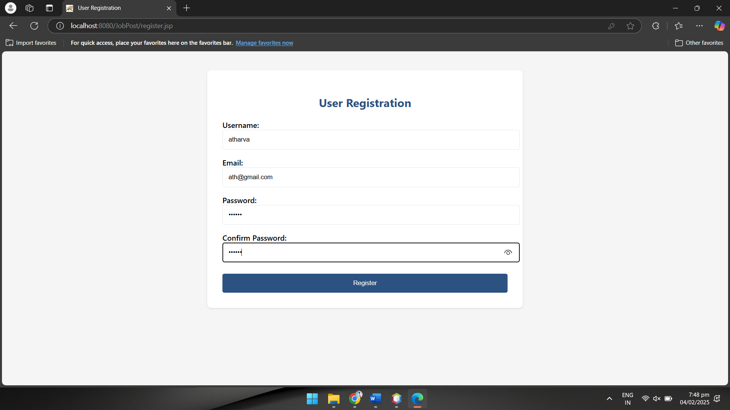

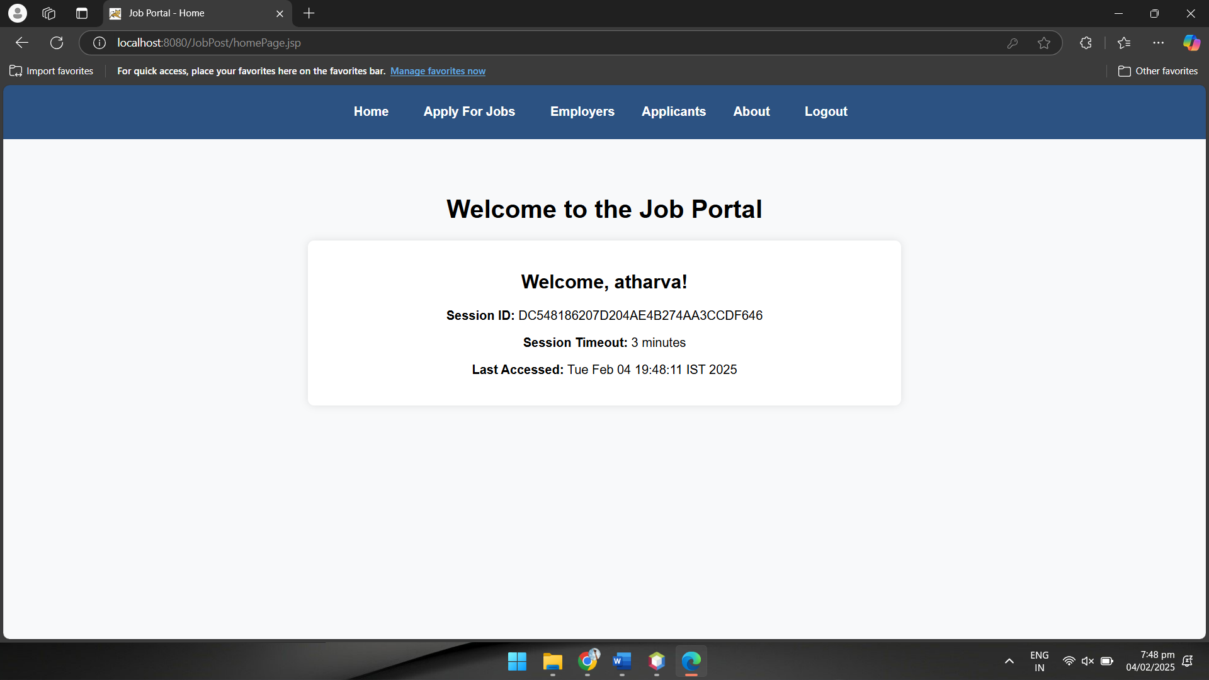

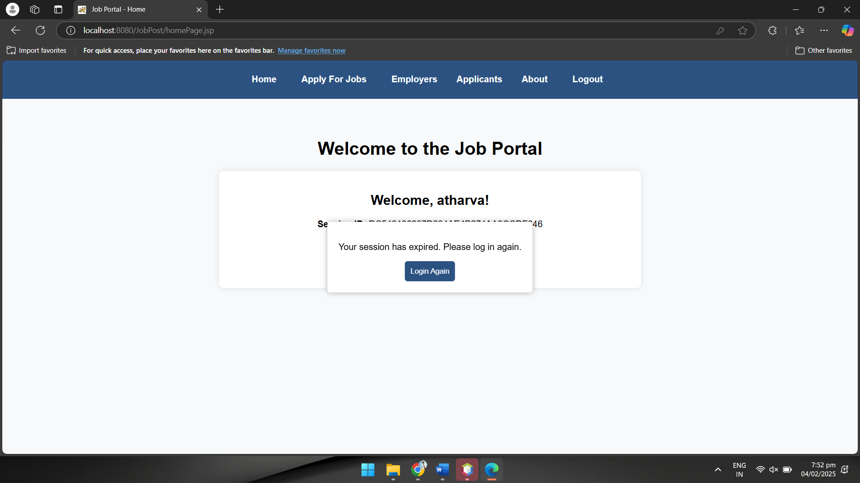

Observation:

JSP allows us to create dynamic web pages by embedding Java code within HTML. Using session management techniques like HTTP sessions, cookies, and URL rewriting, we can maintain user data across multiple requests. This helps in storing and retrieving user-specific information such as login details and cart items. To ensure security, measures like regenerating session IDs and using HTTPS can prevent session hijacking and fixation. Additionally, setting session timeouts and properly invalidating sessions helps improve security and optimize resource usage.